Mass Transport
Craig M. Bethke and Brian Farrell
Task 1: Migration of a non-reacting contaminant
Let’s construct a model of how a contaminant might migrate in flowing groundwater, neglecting for the moment the possibility of chemical reaction.
In our model, inorganic Pb contamination passes into an aquifer. After 2 years, the source is removed and the aquifer is flushed with ambient water.
Double-click on file “Pulse.x1t” and look at the Initial pane in X1t
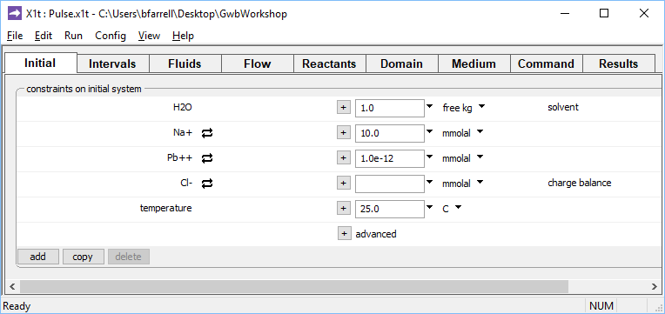
Clean water
We’ve specified here that the aquifer be filled initially with clean water.
Moving to the Intervals pane
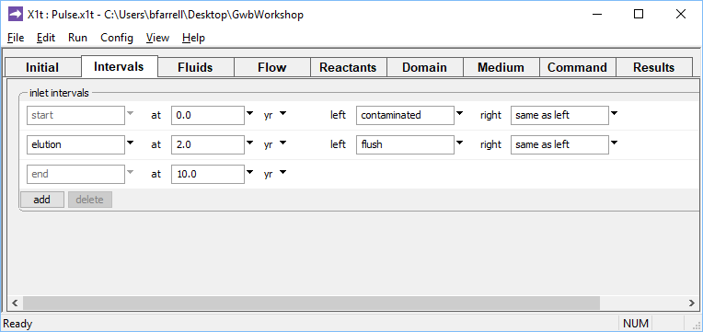
The first interval runs from 0 to 2 years. The second interval runs from 2 to 10 years.
we’ve set start and end times for two reaction intervals, the imbibition and elution legs of the simulation. We’ve additionally designated two fluids, “contaminated” and “flush”, to flow into the left side of the domain during the imbibition (start) and elution intervals, respectively.
The Fluids pane contains the two boundary fluids
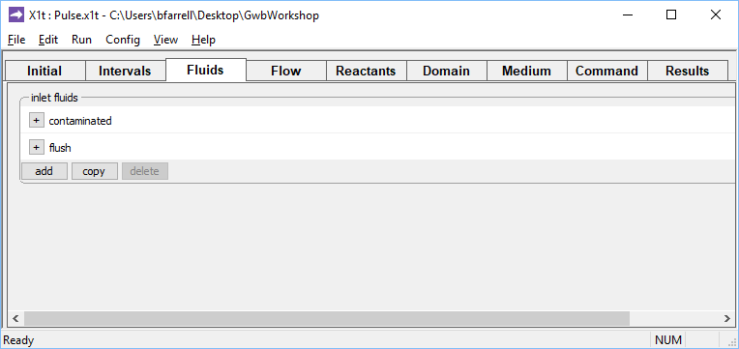
Click to expand
By expanding the “+” signs, we can view the “contaminated” fluid, which will be introduced in the imbibition leg
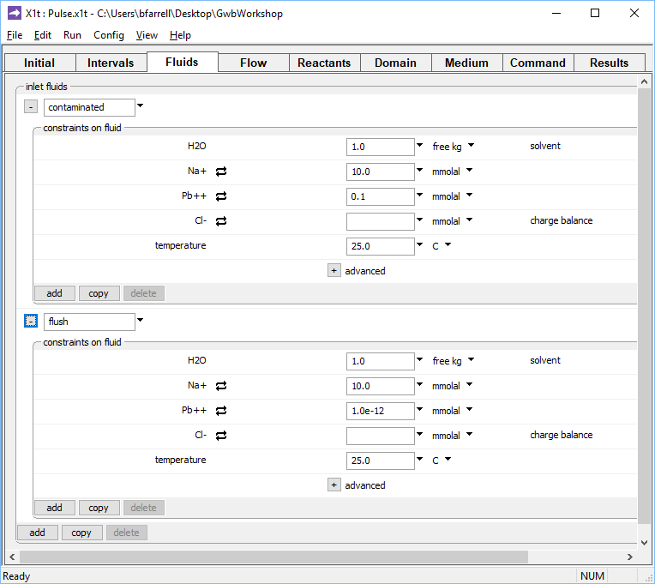
Water contains
20 mg kg^{–1} Pb²⁺
Clean rinse water
as well as the “flush” fluid: clean rinse water that will flow in during elution.
On the Medium pane you can see the values set for porosity and dispersivity
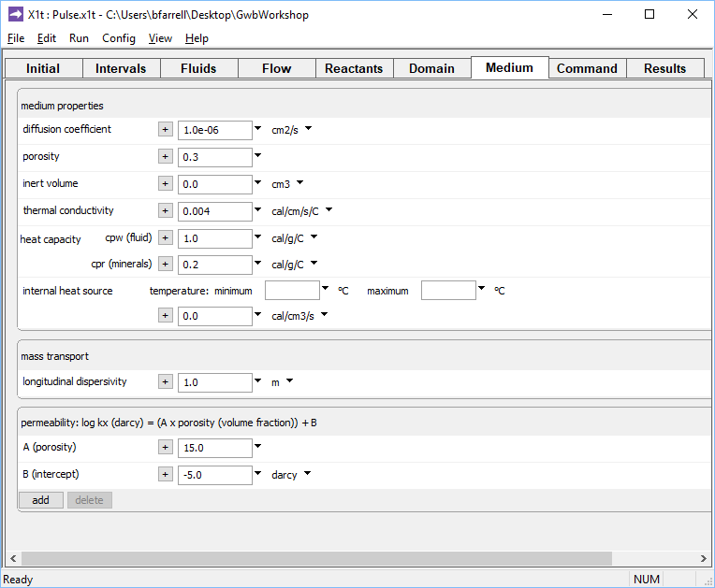
n = 30% porosity
α_{L} = 1 m

Check the domain size and gridding by moving to the Domain pane
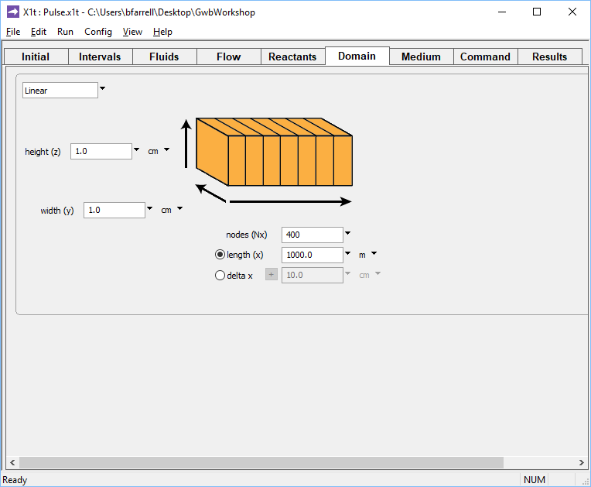
Domain is divided into 400 nodal blocks, 1 km long
We set the rate at which fluid passes into the domain by moving to the Flow pane
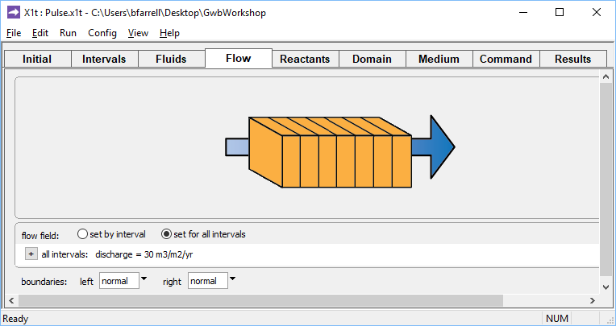
q_{x} = 30 m³ m^{–2} yr^{–1}
(v_{x} = q_{x}/n = 100 m yr^{–1})
A positive specific discharge indicates that fluid will flow from left to right. The simulation spans 10 years, so given the porosity and discharge values we’ve set, the fluid in the aquifer will be displaced once over the course of the simulation.

Before launching the run, go to Config → Output… and enter “_pulse” in the suffix field
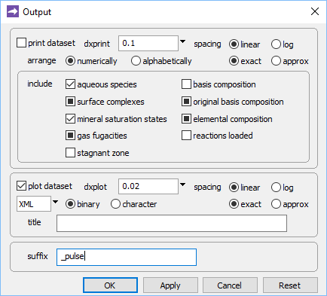
The suffix will be appended to the names of your output datasets, so you can go back to examine the results without rerunning the model. Click OK.
Trigger the calculation by selecting Run → Go. X1t will move to the Results pane, trace the simulation, and when it’s done, offer to extend the run
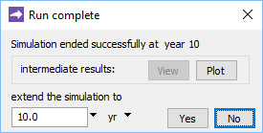
Click No.

Now, look at the bottom of the Results pane
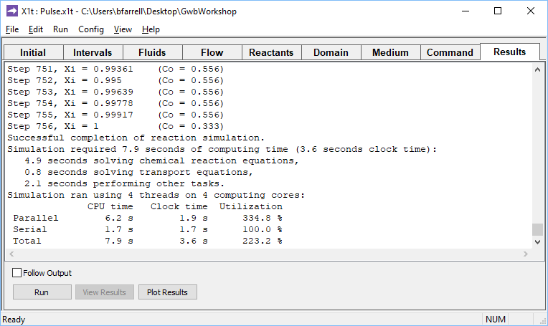
and click on the Plot Results button to launch Xtplot.
Configure the plot as indicated below
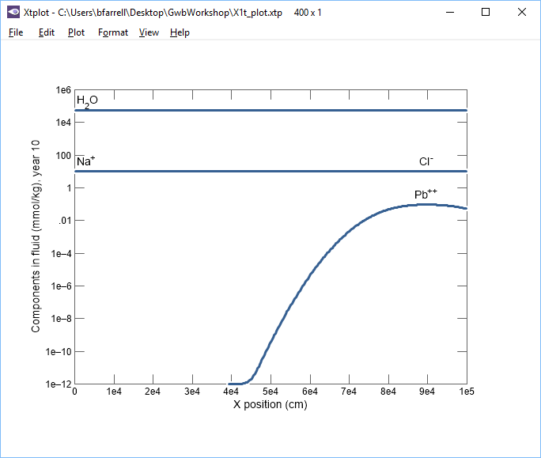
Double-click axis label, select variable type “Components in fluid”, choose variable “Pb++”. Set “mmol/kg” units and a linear axis.
Double-click label, select Display “X position”.
Set units to “m”. Go to “Time Level” pane, select Display “One value at several times”, then choose a time level—or several—and click “Apply”.
Your diagram should look like this:
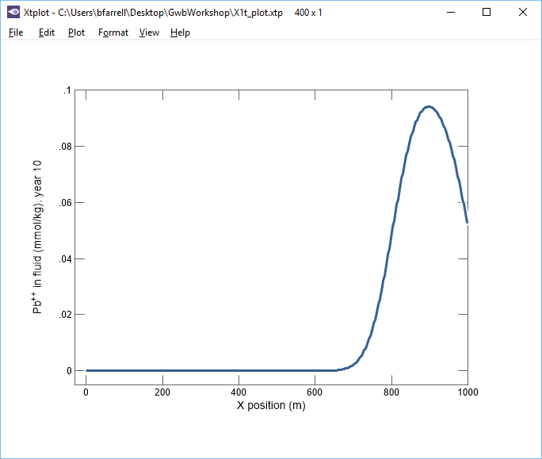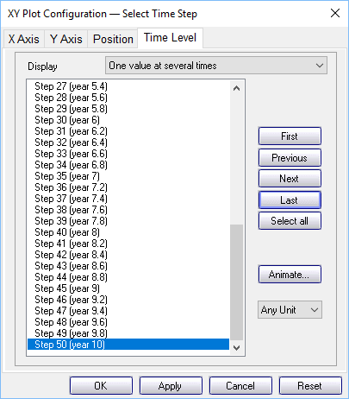
Now, let’s animate the plot. On the XY Plot dialog, go to the Y Axis pane and uncheck the “Auto-scale” option
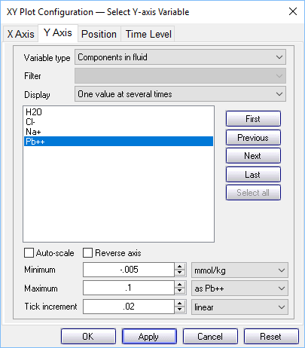
In this way, you hold steady the y‐axis range over the animation. Then, on the main window, choose Format → Animate…
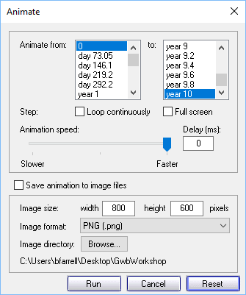
and click on the Run button. How does the shape of the pulse change as it traverses the aquifer from left to right?
Task 2: Effects of dispersion
How does dispersion affect contaminant migration? Let’s find out.
Go to the Medium pane and change the entry for dispersivity from “1 m” to “10 m”
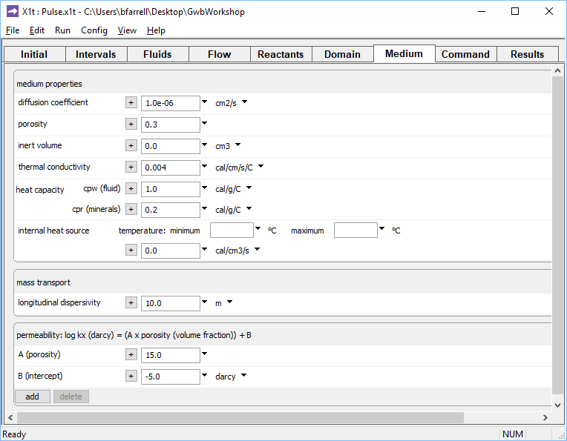
On Config → Output… set a new suffix “_disp”
Click OK, then on the main window select Run → Go. When X1t finishes, launch Xtplot to render the results. Compared to the first model, how have the results changed?
You can compare side-by-side instances of Xtplot. Double-click on “X1t_plot_pulse.xtp” to render your earlier results. If you feel ambitious, you can build up a composite diagram in MS PowerPoint to show both results in one diagram.

© Copyright 2016– Aqueous Solutions LLC. This document may be reproduced and modified freely to support any licensed use of The Geochemist’s Workbench® software, provided that any derived materials acknowledge original authorship.

